B.

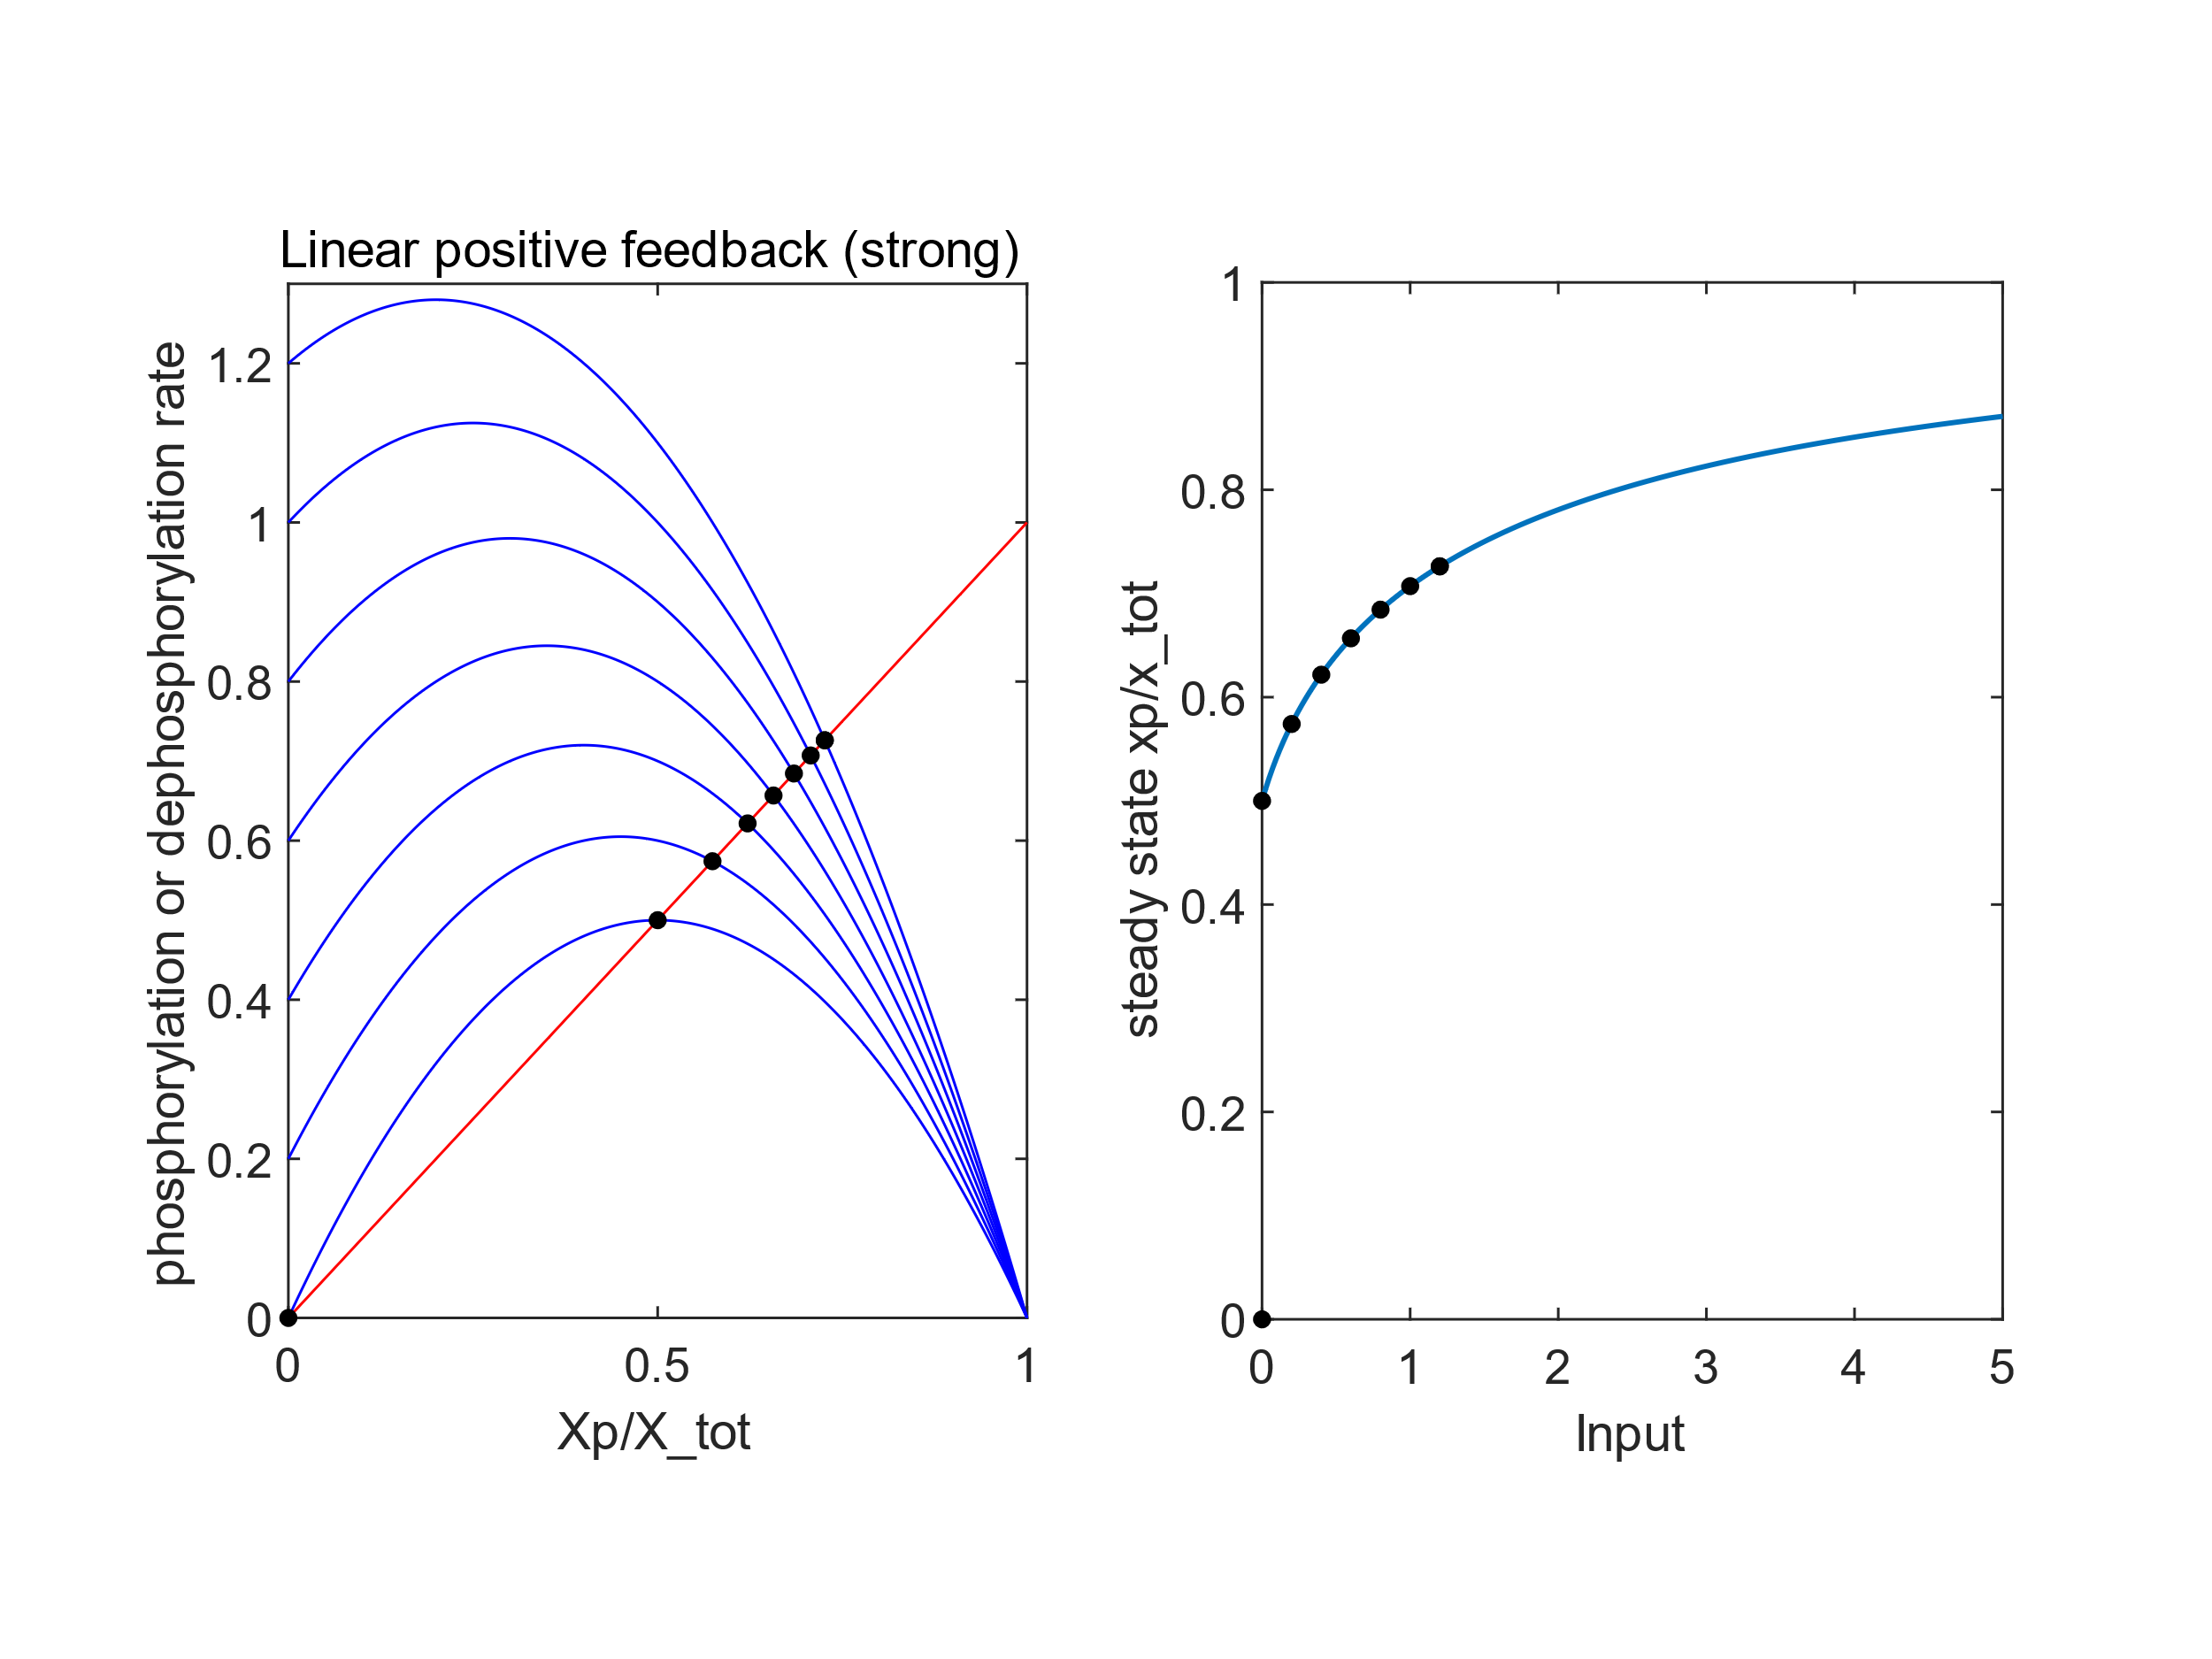

dephospho-rylation

phosphorylation

C.

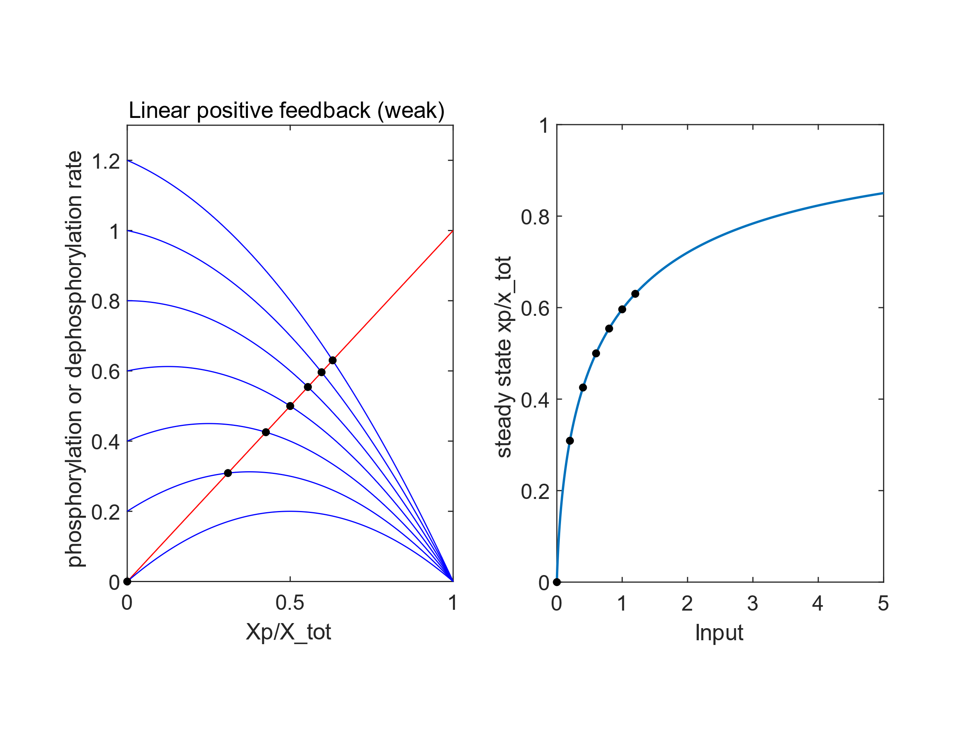

dephosphorylation

phosphorylation

D.

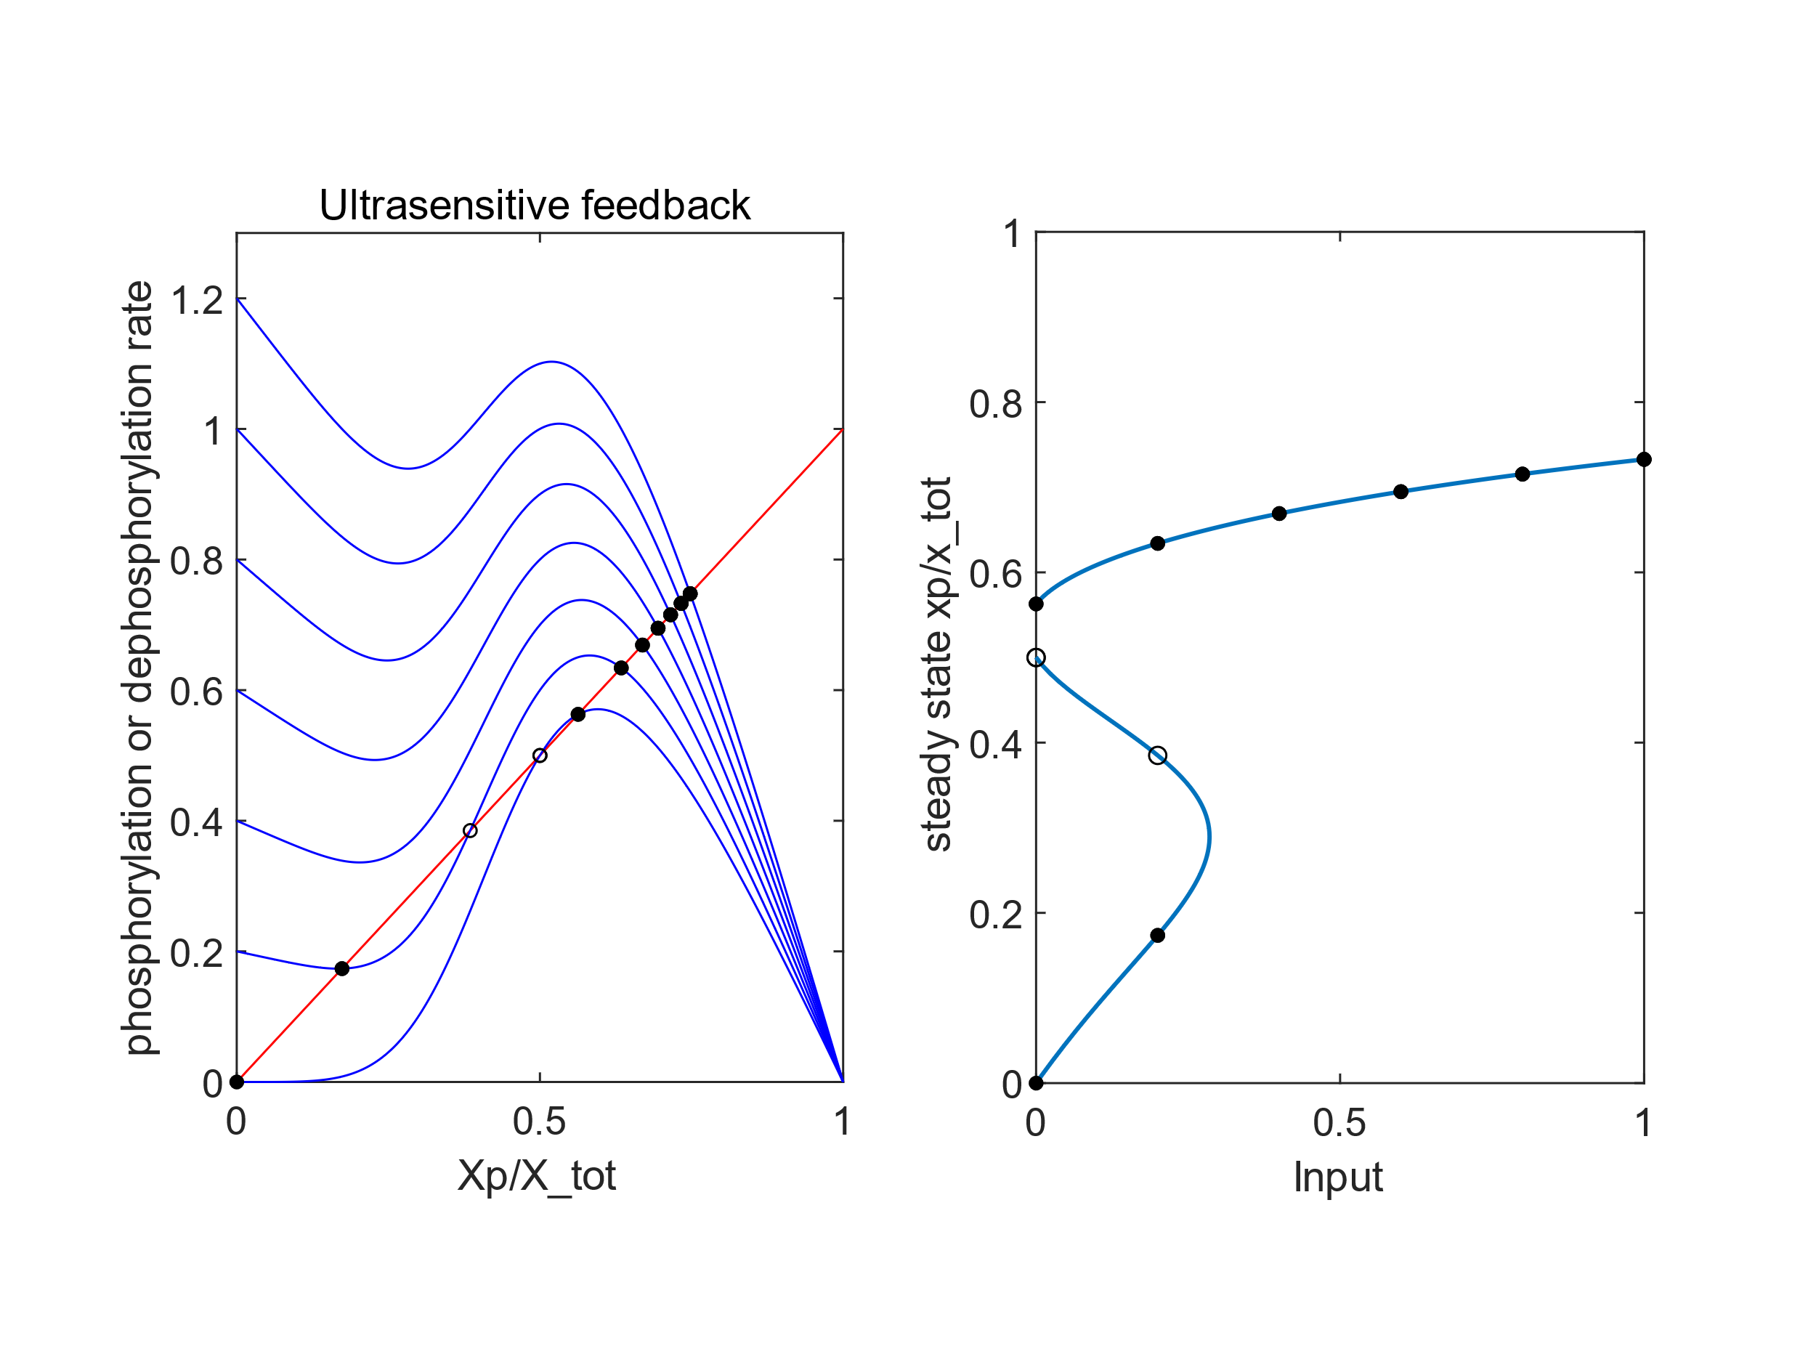

Monostable

Bistable

Dephospho-

rylation

phosphorylation

E.

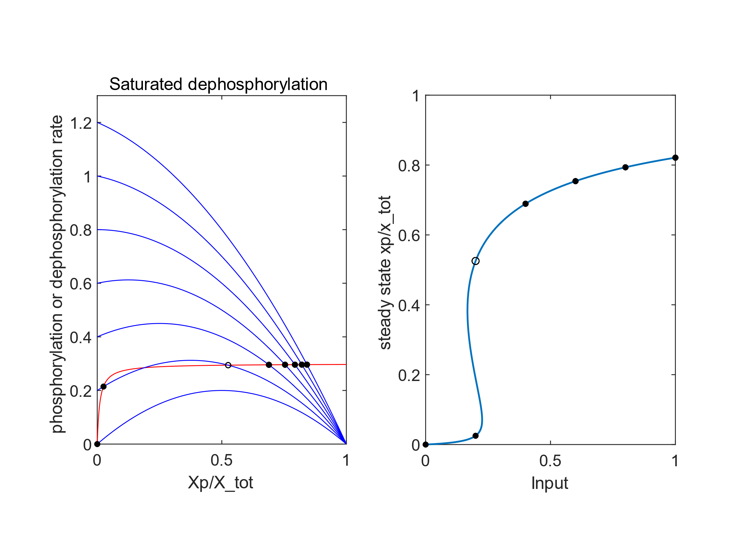

Monostable

Monostable

Bistable

dephosphorylation

phosphorylation